**Report on Temperature Sensor Observation**

1. Location of the pump: Dumuria Government primary School, Dumuria.
2. GPS of the location: Latitude 22.799719 and Longitude 89.419895;
3. Sensor placed in this pump on 09 December 2023 at 11:45 am and sensor removed from this pump on 12 December 2023 at 12:05 pm.
4. Data collected on 10 December 2023 (Day-1) and 11 December 2023 (Day-2);
5. During the period of sensor placing and sensor removal the pump was only used by an enumerator and he used the pump to make water flow at times stated in bellow table:

**Table 1: Pump use times**

|  |  |  |  |  |  |
| --- | --- | --- | --- | --- | --- |
| **Day 1**  **(**10 December 2023 | |  | | **Day 2**  **(**11 December 2023) | |
| **Start** | **Stop** | |  | **Start** | **Stop** |
| 9:00 | 9:05 | |  | 9:30 | 9:35 |
| 9:20 | 9:22 | |  | 9:50 | 9:52 |
| 10:15 | 10:20 | |  | 10:15 | 10:20 |
| 12:20 | 12:23 | |  | 10:22 | 10:23 |
| 12:40 | 12:44 | |  | 10:25 | 10:28 |
| 2:30 | 2:33 | |  | 10:30 | 10:33 |
| 2:40 | 2:41 | |  | 10:40 | 10:45 |
| 2:52 | 2:55 | |  | 10:47 | 10:50 |
| 3:05 | 3:10 | |  | 10:51 | 10:54 |
| 5:30 | 5:32 | |  | 11:30 | 11:34 |
| 5:40 | 5:41 | |  | 2:40 | 2:44 |
| 5:50 | 5:55 | |  | 2:48 | 2:50 |
| 20:00 | 20:05 | |  | 2:52 | 2:55 |

1. Outside (ambient) temperature and the temperature of the water from the pump in the morning and afternoon; To measure the water temperature of water from the pump **“Portable Multi-Meter was used”.**

|  |  |  |
| --- | --- | --- |
| **Date** | **Outside (ambient) temperature** | **temperature of the water from the pump** |
| **10 December 2023 (Day-1)** | Time: Morning (9:05am)  Temp: 22°C | Time: Morning (9:07am)  Temp: 26°C |
| Time: Afternoon (5:32pm)  Temp: 27°C | Time: Afternoon (5:35pm)  Temp: 25°C |
| **11 December 2023 (Day-2)** | Time: Morning (9:35am)  Temp: 19°C | Time: Morning (9:38am)  Temp: 25°C |
| Time: Afternoon (2:55pm)  Temp: 26°C | Time: Afternoon (2:57pm)  Temp: 27°C |

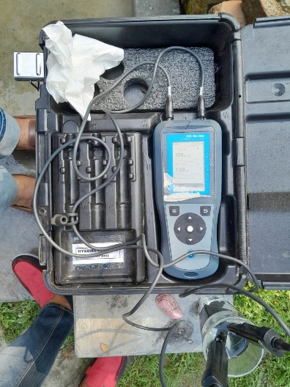

**Portable Multi-Meter**

1. During testing period of Day-1 and Day-2 there was no rain;
2. Sensor data was retrieve on 12 December 2023 (day after the test) and removed the sensor.
3. Sensor data is attached herewith.